Stack
- Stack is an ordered list in which, insertion and deletion can be performed only at one end that is called top.
- Stack is a recursive data structure having pointer to its top element.
- Stacks are sometimes called as Last-In-First-Out (LIFO) lists i.e. the element which is inserted first in the stack, will be deleted last from the stack.

Operations on Stack
There are various operations which can be performed on stack.
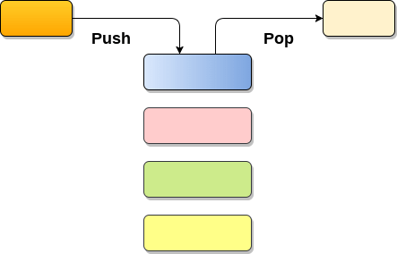
1. Push : Adding an element onto the stack
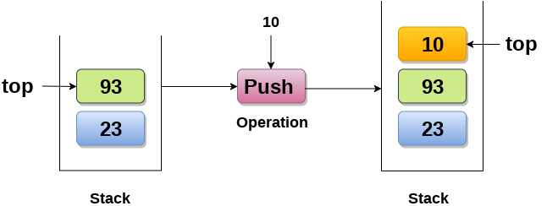
2. Pop : Removing an element from the stack
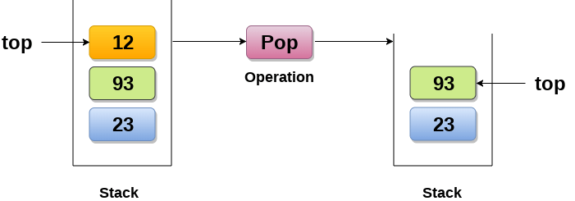

How the stack grows?
Scenario 1 : Stack is empty
The stack is called empty if it doesn't contain any element inside it. At this stage, the value of variable top is -1.
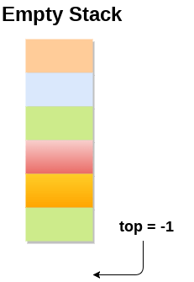

Scenario 2 : Stack is not empty
Value of top will get increased by 1 every time when we add any element to the stack. In the following stack, After adding first element, top = 2.
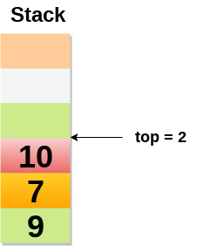
Scenario 3 : Deletion of an element
Value of top will get decreased by 1 whenever an element is deleted from the stack.
In the following stack, after deleting 10 from the stack, top = 1.
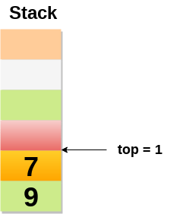

Top and its value :
Top position | Status of stack
-1 | Empty
0 | Only one element in the stack
N-1 | Stack is full
N | Overflow

Array implementation of Stack
In array implementation, the stack is formed by using the array. All the operations regarding the stack are performed using arrays. Lets see how each operation can be implemented on the stack using array data structure.

Adding an element onto the stack (push operation)
Adding an element into the top of the stack is referred to as push operation. Push operation involves following two steps.
- Increment the variable Top so that it can now refere to the next memory location.
- Add element at the position of incremented top. This is referred to as adding new element at the top of the stack.
Stack is overflown when we try to insert an element into a completely filled stack therefore, our main function must always avoid stack overflow condition.
Algorithm:
begin
if top = n then stack full
top = top + 1
stack (top) : = item;
end

implementation of push algorithm in C language
void push (int val,int n) //n is size of the stack
{
if (top == n )
printf("\n Overflow");
else
{
top = top +1;
stack[top] = val;
}
}

Deletion of an element from a stack (Pop operation)
Deletion of an element from the top of the stack is called pop operation. The value of the variable top will be incremented by 1 whenever an item is deleted from the stack. The top most element of the stack is stored in an another variable and then the top is decremented by 1. the operation returns the deleted value that was stored in another variable as the result.
The underflow condition occurs when we try to delete an element from an already empty stack.
Algorithm :
begin
if top = 0 then stack empty;
item := stack(top);
top = top - 1;
end;

Implementation of POP algorithm using C language
int pop ()
{
if(top == -1)
{
printf("Underflow");
return 0;
}
else
{
return stack[top - - ];
}
}

Visiting each element of the stack (Peek operation)
Peek operation involves returning the element which is present at the top of the stack without deleting it. Underflow condition can occur if we try to return the top element in an already empty stack.
Algorithm :
PEEK (STACK, TOP)
Begin
if top = -1 then stack empty
item = stack[top]
return item
End
Time complexity: o(n)

Implementation of Peek algorithm in C language
int peek()
{
if (top == -1)
{
printf("Underflow");
return 0;
}
else
{
return stack [top];
}
}
C program
#include <stdio.h>
int stack[100],i,j,choice=0,n,top=-1;
void push();
void pop();
void show();
void main ()
{

printf("Enter the number of elements in the stack ");
scanf("%d",&n);
printf("*********Stack operations using array*********");

printf("\n----------------------------------------------\n");
while(choice != 4)
{
printf("Chose one from the below options...\n");
printf("\n1.Push\n2.Pop\n3.Show\n4.Exit");
printf("\n Enter your choice \n");
scanf("%d",&choice);
switch(choice)
{
case 1:
{
push();
break;
}
case 2:
{
pop();
break;
}
case 3:
{
show();
break;
}
case 4:
{
printf("Exiting....");
break;
}
default:
{
printf("Please Enter valid choice ");
}
};
}
}

void push ()
{
int val;
if (top == n )
printf("\n Overflow");
else
{
printf("Enter the value?");
scanf("%d",&val);
top = top +1;
stack[top] = val;
}
}

void pop ()
{
if(top == -1)
printf("Underflow");
else
top = top -1;
}
void show()
{
for (i=top;i>=0;i--)
{
printf("%d\n",stack[i]);
}
if(top == -1)
{
printf("Stack is empty");
}
}

